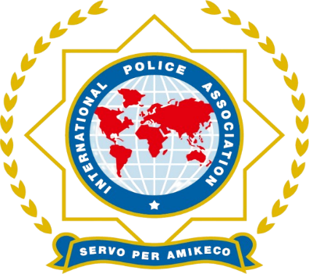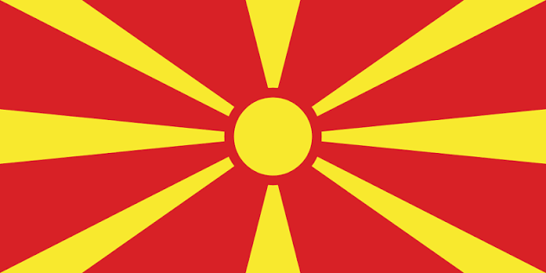
INTERNATIONAL POLICE ASSOCIATION
NATIONAL SECTION OF THE REPUBLIC OF NORTH MACEDONIA
IPA REGION STRUMICA

PROGRAMME
of the Regular Annual and Electoral Assembly of IPA Region Strumica and the “IPA MEGDAN 2026” International Shooting Tournament
15–18 OCTOBER 2026 | STRUMICA, NORTH MACEDONIA

Thursday – 15 October 2026
17:00–19:00 – Arrival of international guests and check-in at “Thermal Lux & Spa” Hotel – Bansko, Strumica
20:00 – Dinner and social gathering

Friday – 16 October 2026
07:00–09:00 – Breakfast at the hotel
10:00 – Visit to a local winery, wine tasting, and visit to the “Kolesino Waterfalls”
13:00 – Lunch at a traditional local restaurant
14:00 – Return to the hotel
16:30–17:00 – Registration of delegates and guests for the Regular Annual and Electoral Assembly of IPA Region Strumica
17:30 – Opening ceremony and group photo.
18:00–19:30 – Working session of the Regular Annual and Electoral Assembly
20:00 – Dinner

Saturday – 17 October 2026
07:00–09:00 – Breakfast at the hotel
09:00 – Departure to the “MEGDAN” Shooting Range – Popchevo Village
10:00 – Official opening of the tournament with welcoming speeches
10:30–14:00 – Competitive part of the shooting tournament
14:00–17:00 – Lunch and social gathering at the “Megdan” Shooting Range
17:00 – Return to the hotel
20:00 – Gala dinner, award ceremony and gift exchange

Sunday – 18 October 2026
07:00–10:00 – Breakfast and departure of the guests

President of IPA N.S North Macedonija
Mr. Igno Stojkov
President od IPA Region Strumica
Mr. Vasil Todorov
SERVO PER AMIKECO

